## Homework 6

First off, I set the working directory and load the ggplot2, gplots, and dplyr packages.

library(ggplot2)  
library(gplots)

##   
## Attaching package: 'gplots'

## The following object is masked from 'package:stats':  
##   
## lowess

library(dplyr)

##   
## Attaching package: 'dplyr'

## The following objects are masked from 'package:stats':  
##   
## filter, lag

## The following objects are masked from 'package:base':  
##   
## intersect, setdiff, setequal, union

Next I read in the data set for homework 6.

dat<-read.csv("homework6.csv")

Now, I am able to check the structure.

str(dat)

## 'data.frame': 48 obs. of 5 variables:  
## $ rt : num 348 309 291 333 315 ...  
## $ type : Factor w/ 2 levels "conjunction",..: 2 2 2 2 2 2 2 2 2 2 ...  
## $ distractors: int 4 4 4 4 4 4 4 4 8 8 ...  
## $ subject : int 1 2 3 4 5 6 7 8 1 2 ...  
## $ subject2 : int 1 2 3 4 5 6 7 8 1 2 ...

I notice that distractors, subject, and subject2 should be factor variables. I change that with the following r chunk.

dat$distractors<-as.factor(dat$distractors)  
dat$subject<-as.factor(dat$subject)  
dat$subject2<-as.factor(dat$subject2)

Now, I am able to perform a one-way between-subjects ANOVA to examine the conjunction searches and determine what effect, if any, the number of distractors had on them.

The first step is to get only the data from the conjunction trials.

temp<-dat[dat$type=="conjunction",]

Then I can perform a one way between-subjects ANOVA.

summary(aov(rt~distractors, data=temp))

## Df Sum Sq Mean Sq F value Pr(>F)   
## distractors 2 14078 7039 8.603 0.00187 **  
## Residuals 21 17182 818   
## ---  
## Signif. codes: 0 '***' 0.001 '**' 0.01 '*' 0.05 '.' 0.1 ' ' 1

There is a significant effect for the number of distractors which were present in the conjunction trials F(2,21) = 8.6, p < .01. We can see this even better with a line graph.

temp<-temp%>%group_by(distractors)%>%  
 summarize(means=mean(rt),  
 sems=sd(rt)/sqrt(length(rt)))  
  
f<-ggplot(temp, aes(x=as.factor(distractors),  
 y=means,  
 group=1))+  
 geom_line(size=1)+  
 geom_point(size=2)+  
 geom_errorbar(aes(ymax=means+sems,  
 ymin=means-sems),  
 width=.2)+  
 ggtitle("Effect of Distractors on Performance")+  
 labs(x="Distractors",y="Performance Time")+  
 theme(plot.title=element_text(size=15,face="bold",vjust=.5))+  
 theme(axis.title.x=element_text(size=12,face="bold",vjust=-.25))+  
 theme(axis.title.y=element_text(size=12,face="bold",vjust=1))+  
 theme(axis.text.x=element_text(size=10,face="bold",color="black"))+  
 theme(axis.text.y=element_text(size=10,face="bold",color="black"))+  
 coord_cartesian(ylim=c(min(temp$means)-2*max(temp$sems),  
 max(temp$means)+2*max(temp$sems)))+  
 theme(panel.border=element_blank(),axis.line=element_line())+  
 theme(panel.grid.major.x=element_blank())+  
 theme(panel.grid.major.y=element_line(color="darkgrey"))+  
 theme(panel.grid.minor.y=element_blank())  
f

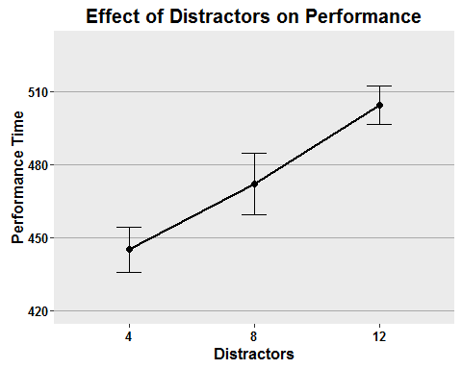 The figure shows that distractors are positively correlated with performance time on the conjunction trials. As the number of distractors increase, the performance times on the task increase which displays a lower level of performance the more distractors there are.

I can also perform a one-way within subjects ANOVA on the data. In order to do this, I need to reset my temporary data file with the following code.

temp<-dat[dat$type=="conjunction",]

Now I am able to perform a one-way within subjects ANOVA on this data.

summary(aov(rt~distractors+  
 Error(subject/distractors),data=temp))

##   
## Error: subject  
## Df Sum Sq Mean Sq F value Pr(>F)  
## Residuals 7 15437 2205   
##   
## Error: subject:distractors  
## Df Sum Sq Mean Sq F value Pr(>F)   
## distractors 2 14078 7039 56.45 1.99e-07 ***  
## Residuals 14 1746 125   
## ---  
## Signif. codes: 0 '***' 0.001 '**' 0.01 '*' 0.05 '.' 0.1 ' ' 1

There was a significant within-subjects effect of the number of distractors on the conjunction trials F(2,14) = 56.0, p < .001. The subjects who had fewer distractors performed better in the trials, the subjects with more distractors performed more slowly.

A between-subjects ANOVA can now be performed to investigate the effects of and interactions between the number of distractors and the type of visual search task.

summary(aov(rt~distractors*type, data=dat))

## Df Sum Sq Mean Sq F value Pr(>F)   
## distractors 2 3945 1972 2.648 0.08262 .   
## type 1 342239 342239 459.417 < 2e-16 ***  
## distractors:type 2 11675 5838 7.836 0.00128 **   
## Residuals 42 31288 745   
## ---  
## Signif. codes: 0 '***' 0.001 '**' 0.01 '*' 0.05 '.' 0.1 ' ' 1

The between-subjects ANOVA shows that there was not a significant effect for the number of distractors at the p < .05 level, F(2,42) = 2.6, p < .10. However, there was an effect for the type of visual search F(1,42) = 459.0, p < .001. Additionally, there was an interaction between the number of distractors and the type of visual search, F(2,42) = 7.8, p < .01. The subjects who performed the conjunction search in general performed better when there were fewer distractions.

I can now create graphs to better visualize the results. A line graph and a grouped bar graph with error bars will help to show the findings of our analyses. To begin, I will need to summarize the data.

temp<-dat%>%group_by(distractors,type)%>%  
 summarize(means=mean(rt),  
 sems=sd(rt)/sqrt(length(n)))

Then, I am able to create the graphs.

f<-ggplot(temp, aes(x=distractors,  
 y=means,  
 group=type,  
 color=type))+  
 geom_line(size=1)+  
 geom_point(size=2)+  
 scale_color_manual(values=c("darkgreen","red"),  
 name="Type",  
 breaks=c("conjunction","feature"),  
 labels=c("conjunction", "feature"))+  
 geom_errorbar(aes(ymax=means+sems, ymin=means-sems),width=.2)+  
 ggtitle("Performance by Type with Distractors")+  
 labs(x="Distractors",y="Performance Time")+  
 theme(plot.title=element_text(size=15,face="bold",vjust=.5))+  
 theme(axis.title.x=element_text(size=12,face="bold",vjust=-.25))+  
 theme(axis.title.y=element_text(size=12,face="bold",vjust=1))+  
 theme(axis.text.x=element_text(size=10,face="bold",color="black"))+  
 theme(axis.text.y=element_text(size=10,face="bold",color="black"))+  
 coord_cartesian(ylim=c(min(temp$means)-2*max(temp$sems),  
 max(temp$means)+2*max(temp$sems)))+  
 theme(panel.border=element_blank(),axis.line=element_line())+  
 theme(panel.grid.major.x=element_blank())+  
 theme(panel.grid.major.y=element_line(color="darkgrey"))+  
 theme(panel.grid.minor.y=element_blank())+  
 theme(legend.position=c(.4,.76))+  
 theme(legend.background=element_blank())+  
 theme(legend.background=element_rect(color="black"))+  
 theme(legend.title=element_blank())+  
 theme(legend.title=element_text(size=12))+  
 theme(legend.title.align=.5)+  
 theme(legend.text=element_text(size=10,face="bold"))  
f

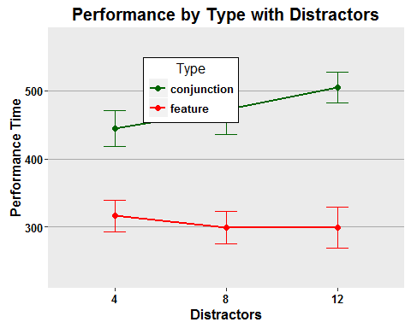

f<-ggplot(temp, aes(x=distractors,  
 y=means,  
 fill=type))+  
 geom_bar(stat="identity",position=position_dodge())+  
 scale_fill_manual(values=c("darkgreen","red"),  
 name="Type",  
 breaks=c("conjunction","feature"),  
 labels=c("conjunction", "feature"))+  
 geom_errorbar(aes(ymax=means+sems,  
 ymin=means-sems),  
 width=.2,  
 position=position_dodge(.9))+  
 ggtitle("Performance by Type with Distractors")+  
 labs(x="Distractors",y="Performance Time")+  
 theme(plot.title=element_text(size=15,face="bold",vjust=.5))+  
 theme(axis.title.x=element_text(size=12,face="bold",vjust=-.25))+  
 theme(axis.title.y=element_text(size=12,face="bold",vjust=1))+  
 theme(axis.text.x=element_text(size=10,face="bold",color="black"))+  
 theme(axis.text.y=element_text(size=10,face="bold",color="black"))+  
 coord_cartesian(ylim=c(min(temp$means)-2*max(temp$sems),  
 max(temp$means)+2*max(temp$sems)))+  
 theme(panel.border=element_blank(),axis.line=element_line())+  
 theme(panel.grid.major.x=element_blank())+  
 theme(panel.grid.major.y=element_line(color="darkgrey"))+  
 theme(panel.grid.minor.y=element_blank())+  
 theme(legend.position=c(.4,.76))+  
 theme(legend.background=element_blank())+  
 theme(legend.background=element_rect(color="black"))+  
 theme(legend.title=element_blank())+  
 theme(legend.title=element_text(size=12))+  
 theme(legend.title.align=.5)+  
 theme(legend.text=element_text(size=10,face="bold"))  
f

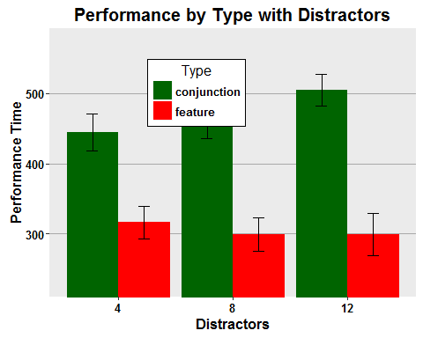 The figures show that the subjects in the visual condition Conjunction in general performed more poorly the greater the distractions and performed more poorly overall than subjects in the Feature condition. The subjects in the visual condition Feature in general did not experience the effect of the number of distractors and they performed better overall than their counterparts in the Conjunction visual condition.

To better examine the effects of and interactions between the search type and the number of distractors, I can perform a within-subjects two-way ANOVA.

summary(aov(rt~distractors*type+  
 Error(subject/(distractors*type)),  
 data=dat))

##   
## Error: subject  
## Df Sum Sq Mean Sq F value Pr(>F)  
## Residuals 7 24790 3541   
##   
## Error: subject:distractors  
## Df Sum Sq Mean Sq F value Pr(>F)   
## distractors 2 3945 1972.3 11.16 0.00127 **  
## Residuals 14 2475 176.8   
## ---  
## Signif. codes: 0 '***' 0.001 '**' 0.01 '*' 0.05 '.' 0.1 ' ' 1  
##   
## Error: subject:type  
## Df Sum Sq Mean Sq F value Pr(>F)   
## type 1 342239 342239 1626 1.5e-09 ***  
## Residuals 7 1473 210   
## ---  
## Signif. codes: 0 '***' 0.001 '**' 0.01 '*' 0.05 '.' 0.1 ' ' 1  
##   
## Error: subject:distractors:type  
## Df Sum Sq Mean Sq F value Pr(>F)   
## distractors:type 2 11675 5838 32.05 5.95e-06 ***  
## Residuals 14 2550 182   
## ---  
## Signif. codes: 0 '***' 0.001 '**' 0.01 '*' 0.05 '.' 0.1 ' ' 1

The results show the greater number of distractors present, the slower the performance time F(2,14) = 11.2, p < .01. They also show that the type of visual search task also effects performance times with Conjunction times in general being slower than Feature times F(1,7) = 1626, p < .001.There is a significant interaction between the number of distractors and the type of visual search task F(2,14) = 32.1, p < .001 which reveals that the slower performance effect of the number of distractors is only present significantly in the Conjunction visual search condition. As shown by this analysis and the previous tables, the Conjunction visual search is effected by the number of distractors with poorer performance in general the greater the number of distractors there are. The Feature visual search in general does not show this effect.

Lastly, a mixed ANOVA can be performed where distraction varies between participants and position varies within participants to see the effects on performance and the interactions between the number of distractors and type of visual search.

summary(aov(rt~distractors*type+  
 Error(subject2/distractors),  
 data=dat))

##   
## Error: subject2  
## Df Sum Sq Mean Sq F value Pr(>F)   
## type 1 342239 342239 182.4 2.02e-09 ***  
## Residuals 14 26263 1876   
## ---  
## Signif. codes: 0 '***' 0.001 '**' 0.01 '*' 0.05 '.' 0.1 ' ' 1  
##   
## Error: subject2:distractors  
## Df Sum Sq Mean Sq F value Pr(>F)   
## distractors 2 3945 1972 10.99 3e-04 ***  
## distractors:type 2 11675 5838 32.53 4.98e-08 ***  
## Residuals 28 5025 179   
## ---  
## Signif. codes: 0 '***' 0.001 '**' 0.01 '*' 0.05 '.' 0.1 ' ' 1

I find that the type of visual task performed by the subjects is significant, F(1,14) = 182.0, p < .001, which confirms my earlier findings that Conjunction visual search is slower than Feature visual search. I also find that the number of distractors is also significant, F(2,28) = 11.0, p < .001, which confirms my earlier finding that the number of distractors does affect the time it takes to perform a visual search task. These results can be explained by the significant interaction I find between the number of distractors and the type of visual search, F(2,28) = 32.5, p < .001, which shows that the number of distractors negatively effects performance on the Conjunction visual search tasks, but not on the Feature visual search tasks.